**# docker pull ubuntu**

**# docker pull nginx**

**# docker pull centos**

**# docker pull ubuntu:18.04**

**# docker pull httpd:2.4**

**# docker images**

**or**

**# docker image ls**

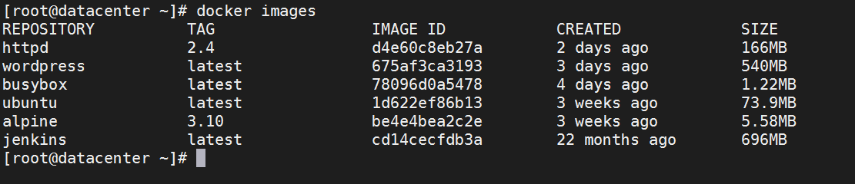

**# docker run hello-world**

**# docker container run -it ubuntu /bin/bash -c hostname**

**# docker container run -itd ubuntu /bin/bash**

**# docker container run -it ubuntu /bin/bash**

**# docker container run -itd -P nginx**

**# docker container run -d nginx**

**# docker container pause container_id**

**# docker container unpause container_id**

**# docker container ls**

**# docker container ls -a**

**or**

**# docker ps**

**# docker ps -a**

**# docker container stop container_id**

**# docker container kill container_id**

**# docker image rm -f image_id**

**# docker rmi image_name**

**# docker container prune -f**

**# docker image prune -f**

**# docker container rename container_id ubuntu_man**

**# docker container start ubuntu_man**

**# docker container stop ubuntu_man**

**# docker container rm -f ubuntu_man**

**# docker container run -itd ubuntu**

**# docker container exec -it ubuntu bash**

**# docker commit container_id new_image_name**

**# docker image ls**

**# docker container rename 9dc587bad3e2 tiger_web**

**# docker container commit --author "Sandeep Anuragi" -m "ubu_20" 30f2446eb65e my_ubu_20**

**# docker image save ubu_20 > ubu_20.tar**

**# docker image load < ubu_20.tar**

**# docker image import < ubu_20.tar**

**# docker container diff 9dc5**

**# docker container wait ac2c08183af7**

**# docker inspect nginx 164**

**# docker search nginx**

**# docker login**

**# docker container tag my_ubu_20 darwikdev11/my_ubu_20**

**# docker image ls**

**# docker push darwikdev11/my_ubu_20**

**# docker rmi -f my_ubu_20**

**# docker pull darwikdev11/my_ubu_20**